**Topcoder Elasticsearch Feeder Service - Jobs Cleanup And Improvement version 1.0**

**Verification Guide**

# 

# Setup

Local setup:

1. Following <https://github.com/appirio-tech/tc-common-tutorials/tree/master/docker/direct-app> to run all dependent services(such as mock services)

1.1 you need to build from the latest code of direct app (see <https://github.com/appirio-tech/tc-common-tutorials/tree/master/docker/direct-app#build-and-run-with-docker-compose>)  
1.2 also the elasticsearch service should be up, run like (docker-compose up -d elasticsearch)  
2. Run the elasticsearch feeder service using mm-features branch, you probably should change the ports (8080, 8081 in src/main/resources/elasticsearch-feeder-service.yaml) due to port conflict.  
3. Create some challenges through direct app, so the elasticsearch feeder will get the data populated into elasticsearch and they will be used by challenge service.

When you try to build the docker image from the last code of tc-direct, make sure that you update the last appiriodevops/tc-database-scripts:latest docker, and after the informix database is started, select the tcs_catalog database run:

select * from client.

If the enable_effort_hours is null, update it to false or true with this sql:

update client set enable_effort_hours = 0;

See Verification_Topcoder - Elasticsearch Feeder Service For Challenges version 1.0.docx about how to create the challenge in the tc-direct app for testing.

select the informixoltp database and run:

update round_segment set start_time = current where segment_id = 1 and round_id = 13672;

update round_segment set start_time = current, end_time = current + 1000 units minute where segment_id = 1 and round_id=13675;

update round set forum_id = 111 where round_id = 13675;

delete from round_prize;

insert into round_prize values (13675, 1, 200);

insert into round_prize values (13675, 2, 100);

delete from round_registration;

insert into round_registration values (13675, 132456, current, 0, null);

insert into round_registration values (13675, 132458, current, 0, null);

delete from round_event;

insert into round_event values (13675, 1, 'event name 1', 'reg url 1');

insert into round_event values (13675, 2, 'event name 2', 'reg url 2');

delete from long_submission;

delete from long_component_state;

insert into long_component_state values (1, 13675, 132456, 2041, 99, 130, 2, 2);

insert into long_submission (long_component_state_id, submission_number, example, open_time, submit_time, submission_points) values (1, 2, 2, 132000, 1517544546857, 99);

delete from long_comp_result;

insert into long_comp_result (round_id, coder_id, placed) values (13675, 132456, 1);

delete from algo_rating where coder_id = 132456;

insert into algo_rating values (132456, 1000, 0, null, 0, 3, current);

See Verification_Topcoder - Create CronJob For Populating Marathon Matches and SRMs To Elasticsearch 1.0.docx for more details about how to create the the marahon matches and single round match data in the database

Use the redis-cli to insert the data.

you can down load the redis client on https://redis.io/

For windows OS, you can download the Redis-x64-3.2.100.zip here: https://github.com/MicrosoftArchive/redis/releases

open the command line and run

redis-cli -h 192.168.99.100 -p 6379

192.168.99.100 should be the docker IP that holds the redis cache service.

Then run the following commands:

hset com.appirio.service.challengefeeder.job.LoadChangedChallengesListingJob.map.cache "\"challengeslisting.job.enable\"" "\"true\""

hset com.appirio.service.challengefeeder.job.LoadChangedChallengesDetailJob.map.cache "\"challengesdetail.job.enable\"" "\"true\""

hset com.appirio.service.challengefeeder.job.LegacyMMToChallengeListingJob.map.cache "\"challengeslisting.job.enable\"" "\"true\""

hset com.appirio.service.challengefeeder.job.LoadChangedMMChallengeDetailJob.map.cache "\"challengesdetail.job.enable\"" "\"true\""

hset com.appirio.service.challengefeeder.job.MarathonMatchesJob.map.cache "\"mmatches.job.enable\"" "\"true\""

hset com.appirio.service.challengefeeder.job.SingleRoundMatchesJob.map.cache "\"srms.job.enable\"" "\"true\""

There is another easy way to configure the enable job flag, just copy the following code to src\main\java\com\appirio\service\challengefeeder\job\BaseJob.java and run the main method in your IDE

**public** **static** **void** main(String[] args) **throws** Exception {

Config redissonConfig = **new** Config();

redissonConfig.useSingleServer().setAddress("redis://192.168.99.100:6379");

RedissonClient client = Redisson.*create*(redissonConfig);

client.getMap("com.appirio.service.challengefeeder.job.LoadChangedChallengesListingJob.map.cache").put("challengeslisting.job.enable", "true");

client.getMap("com.appirio.service.challengefeeder.job.LoadChangedChallengesDetailJob.map.cache").put("challengesdetail.job.enable", "true");

client.getMap("com.appirio.service.challengefeeder.job.LegacyMMToChallengeListingJob.map.cache").put("challengeslisting.job.enable", "true");

client.getMap("com.appirio.service.challengefeeder.job.LoadChangedMMChallengeDetailJob.map.cache").put("challengesdetail.job.enable", "true");

client.getMap("com.appirio.service.challengefeeder.job.MarathonMatchesJob.map.cache").put("mmatches.job.enable", "true");

client.getMap("com.appirio.service.challengefeeder.job.SingleRoundMatchesJob.map.cache").put("srms.job.enable", "true");

client.shutdown();

}

192.168.99.100 should be the docker IP that holds the redis cache service

The configuration values for jobs is(src\main\resources\elasticsearch-feeder-service.yaml):

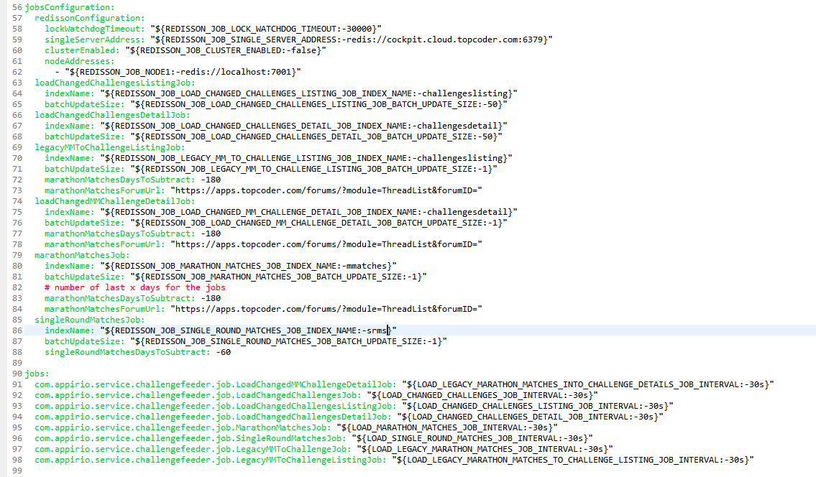

# Verify

Import the Job Cleanup and Improvement.postman_collection.json into the postman.

View challenges in challenges listing index

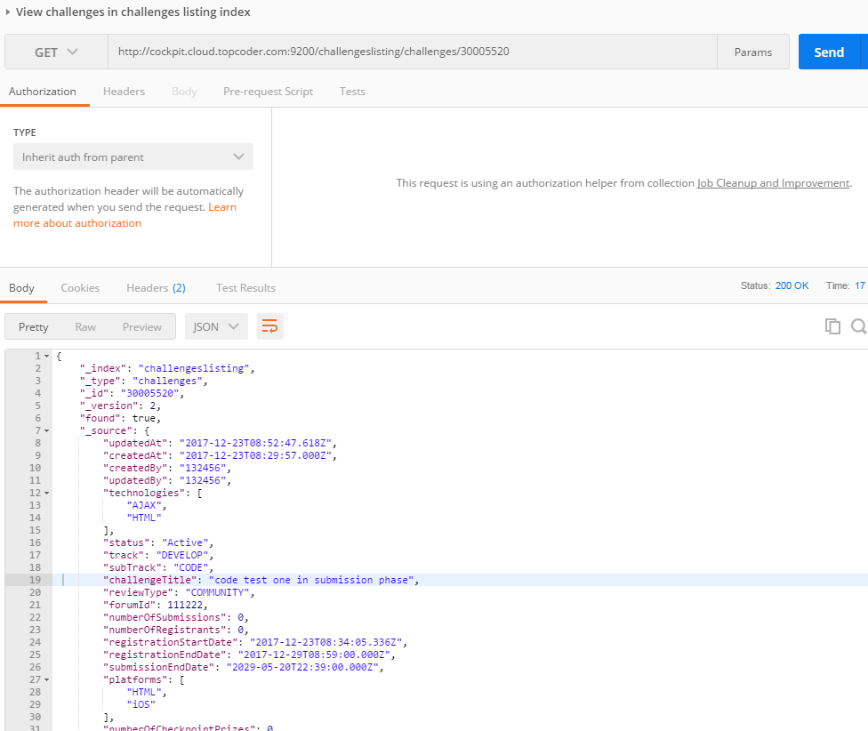

View challenges in challenges details index

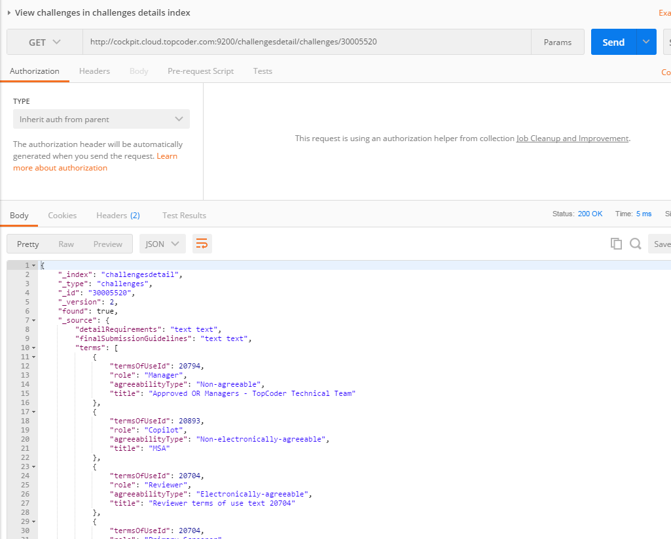

View marachon match in challenges listing index

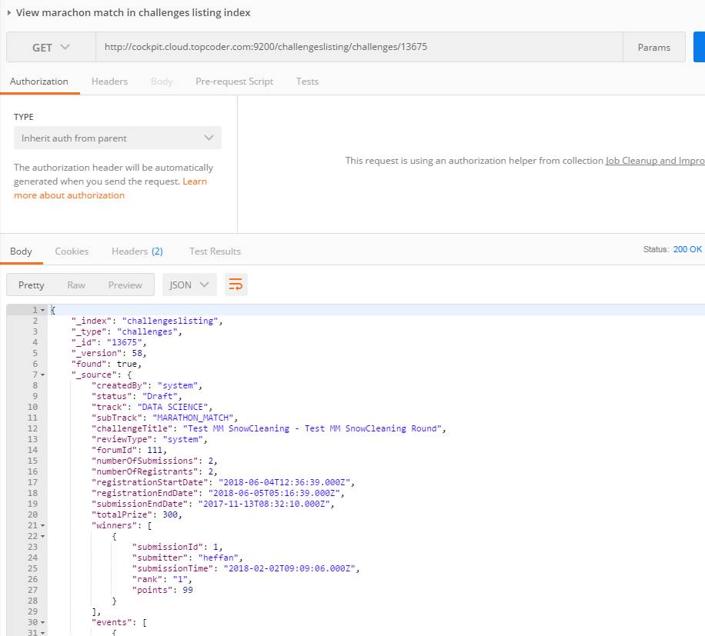

View marathon match in challenges details index

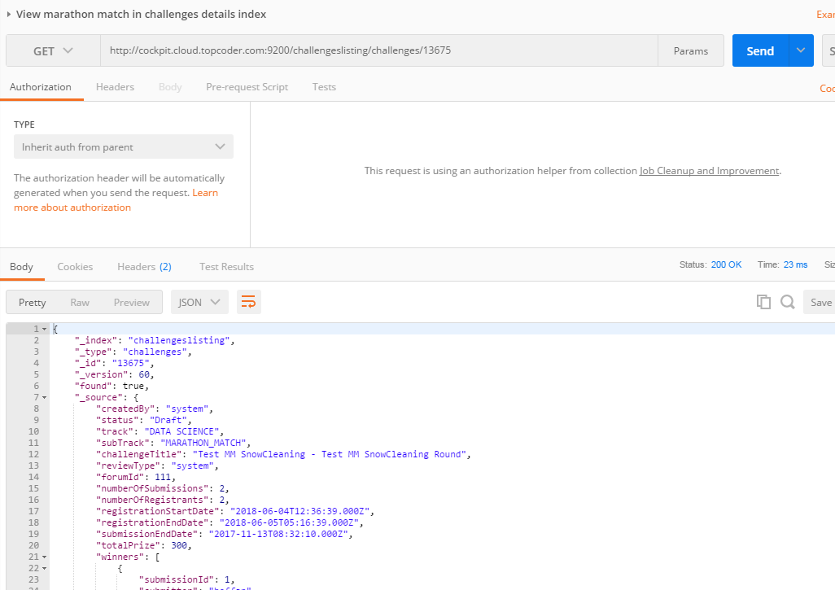

View marathon match

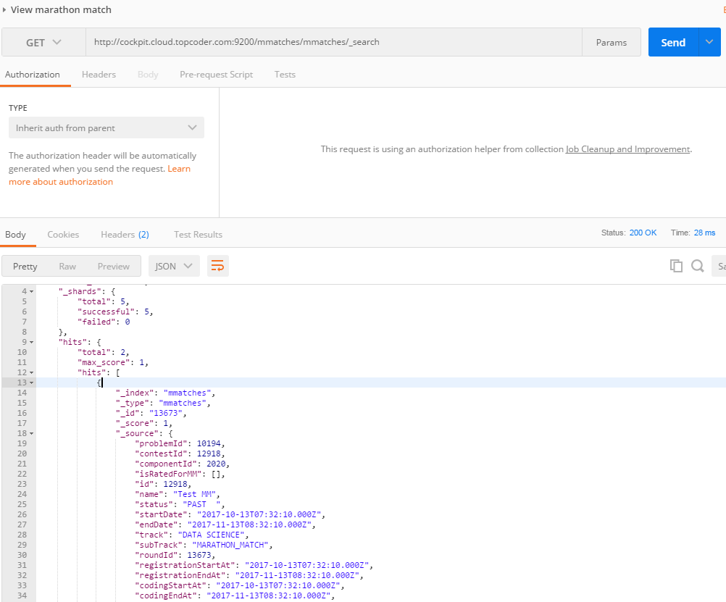

View single round match

